Software Requirements Specification (SRS) for AES Chat Server Project

*Baseline version 0.1*

*Issued on : July 26, 2015*

Issued by : Aurellia, Inc.

Issued for : RobertusHudi Client

**Change History**

|  |  |  |  |
| --- | --- | --- | --- |
| **Version** | **Date** | **Author** | **Changes** |
| 0.1 | July 26, 2015 | RobertusHudi | initial version |
|  |  |  |  |

**Document Approval**

The following Software Requirements Specification has been accepted and approved by the following :

|  |  |  |  |
| --- | --- | --- | --- |
| **Name** | **Title** | **Date** | **Signature** |
| Aurellia | Project Manager | July 28, 2015 |  |
| Robertus Hudi | officer | August 3, 2015 |  |
|  |  |  |  |

**Table of Contents**

1. **INTRODUCTION** 5
   1. PURPOSE 5
   2. SCOPE 4
2. **GENERAL DESCRIPTION** 6
   1. Product Perspective……………………………………………………....6
   2. Product Functions…………………………………………………………6
   3. User Characteristics……………………………………………………….6
   4. General Constraints……………………………………………………….6
   5. Assumptions and Dependencies………………………………………….6
3. **SPECIFIC REQUIREMENTS** 7
   1. External Interface Requirements…………………………………………7
   2. Functional Requirements…………………………………………………7
   3. Use Cases…………………………………………………………………7
   4. Classes/Objects……………………………………………………………7
   5. Non-Functional Requirements……………………………………………..8
4. **ANALYSIS MODELS…………………………………………………………9**
   1. Sequence Diagrams…………………………………………………………9
   2. State-Transition Diagrams (STD)………………………………………….9

**List of Figures**

Figure 1 (Use Cases)……………………………………………………………………………7

Figure 2 (Sequence Diagrams)……………….………………………………………………….9

Figure 3 (State-Transition Diagrams (STD))…………………………………………………….9

**Chapter 1**

**INRODUCTION**

* 1. **Purpose**

The purpose of this project is to create and design the software for RobertusHudi Client, which is designated specifically to help easier chatting and also to protect the privacy of the chat in RobertusHudi company.*.*

* 1. **Scope**
  2. software product name: Project AES chat server
  3. description: this project will help to increase the privacy in chat., this project will encrypted the chat but won’t still encrypted in the chat receiver.
  4. Software description:java programming, user friendly, easy to use,

**Chapter 2**

**GENERAL DESCRIPTION**

1. **Product Perspective**

AES Chat Server is a system that provides functionality described in the product functions section. It includes all subsystems needed to fulfill these software requirements.in addition, interfaces to the external systems. These interfaces shall be implemented according to available industry standards and shall be independent from a specific external system

1. **Product Functions**

Function of the Software:

* It can chat 2 ways or 3 ways
* It provide aes encryption to the client chat so it will increase the privacy
* It written the chat we’ve send into chat log in server. It include time, who send that, and the messages (in encryption if client)

1. **User Characteristics**

All user can be asummed to following characteristics

* Ability to read and understand English
* Familiarity with operation GUI

1. **General Constraints**

General implementation constrains include:

* The software system will run under windows/Mac/Python
* This software must install java jdk and jre
* All code for this software written in Java

1. **Assumptions and Dependencies**

The system should run on any java 2 compatible platform, ot will only be supported on Win32 platform

**Chapter 3**

**SPECIFIC REQUIREMENTS**

1. **External Interface Requirements**

Screen format: chat server, it will display the chat client display and the server. The client will be display the insert chat messages, server address, port number, login button, logout button, and who’s in button

Function key: login button, logout button, who’s in button

1. **Functional Requirements**
   * Send a chat
   * Can know the chat which send before
   * Include chat history

* Can know who’s online

1. **Use Cases**

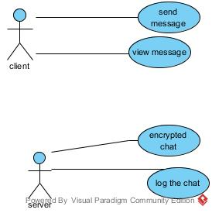

1. **Classes/Objects**

*Class: chat*

*Server*

*Aes encryption*

1. **Non-Functional Requirements**

* Can encrypt the message which send by client (client only)
* The message has been encrypt to AES encryption

**Chapter 4**

**ANALYSIS MODELS**

1. **Sequence Diagrams**

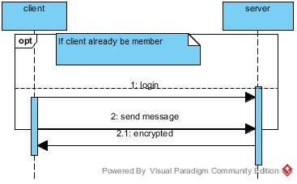

1. **State-Transition Diagrams (STD)**

encrypted

decrypted

connected

connected

Read the message

Send the message

Write the message

insert id that you want

login